FAKE NEWS DETECTION USING NATURAL LANGUAGE PROCESSING

Batch Member

510521104038 : D SARAVANAN

Phase 2
submission document

Project Title:Fake News detection using NLP:-

Phase 2:Innovation

Introduction:
In the past few years, various social media platforms such as Twitter, Facebook, Instagram, etc. have become very popular since they facilitate the easy acquisition of information and Pratik Narang pratik.narang@pilani.bits-pilani.ac.in Rohit Kumar Kaliyar rk5370@bennett.edu.in Anurag Goswami anurag.goswami@bennett.edu.in
- Department of Computer Science Engineering, Bennett University, Greater Noida, India
- Department of CSIS, BITS Pilani, Pilani, Rajasthan, India.



Existing approaches for fake news detection

Detection of fake news is challenging as it is intentionally written to falsify information. The former theories [1] are valuable in guiding research on fake news detection using dif- ferent classification models. Existing learnings for fake news detection can be generally categorized as (i) News Content-based learning and (ii) Social Context-based learning.
News content-based approaches [1, 14, 51, 53] deals with different writing style of pub- lished news articles. In these techniques, our main focus is to extract several features in fake news article related to both information as well as the writing style. Furthermore, fake news publishers regularly have malignant plans to spread mutilated and deluding, requiring specific composition styles to interest and convince a wide extent of consumers that are not present in true news stories. In these learnings, style-based methodologies [12, 35, 53] are helpful to capture the writing style of manipulators using linguistic features for identifying
Diagram:
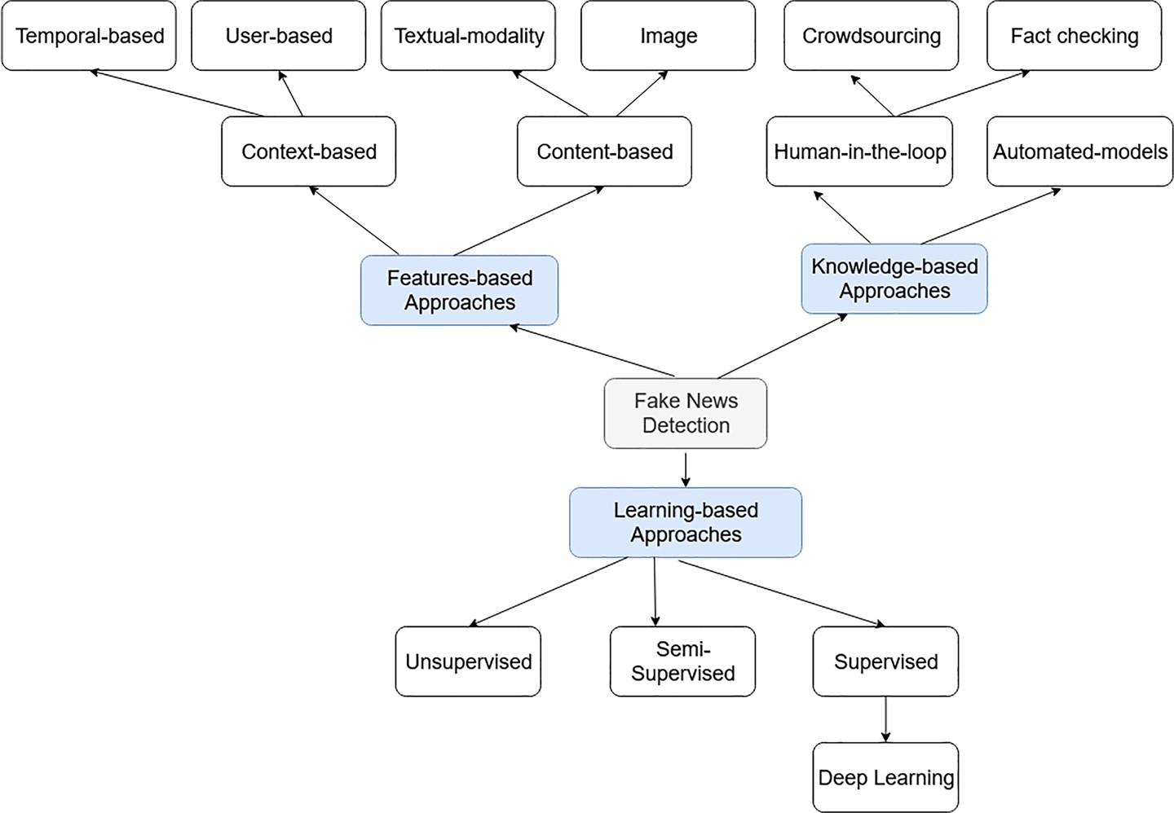

BERT

BERT [11] is a advanced pre-trained word embedding model based on transformer encoded architecture [44]. We utilize BERT as a sentence encoder, which can accurately get the context representation of a sentence [30]. BERT removes the unidirectional constraint using a mask language model (MLM) [44]. It randomly masks some of the tokens from the input and predicts the original vocabulary id of the masked word based only. MLM has increased the capability of BERT to outperforms as compared to previous embedding methods. It is a deeply bidirectional system that is capable of handling the unlabelled text by jointly conditioning on both left and right context in all layers. In this research, we have extracted embeddings for a sentence or a set of words or pooling the sequence of hidden-states for the whole input sequence. A deep bidirectional model is more powerful than a shallow left-to- right and right-to-left model. In the existing research [11], two types of BERT models have been investigated for context-specific tasks, are:
- BERT Base (refer Table 1 for more information about parameters setting): Smaller in size, computationally affordable and not applicable to complex text mining operations.
- BERT Large (refer Table 2 for more information about parameters setting): Larger in size, computationally expensive and crunches large text data to deliver the best results.

Fine-tuning of BERT

Fine-tuning of BERT [11] is a process that allows it to model many downstream tasks, irre- spective of the text form (single text or text pairs). A limited exploration is available to enhance the computing power of BERT to improve the performance on target tasks. BERT model uses a self-attention mechanism to unify the word vectors as inputs that include bidirectional cross attention between two sentences. Mainly, there exist a few fine-tuning

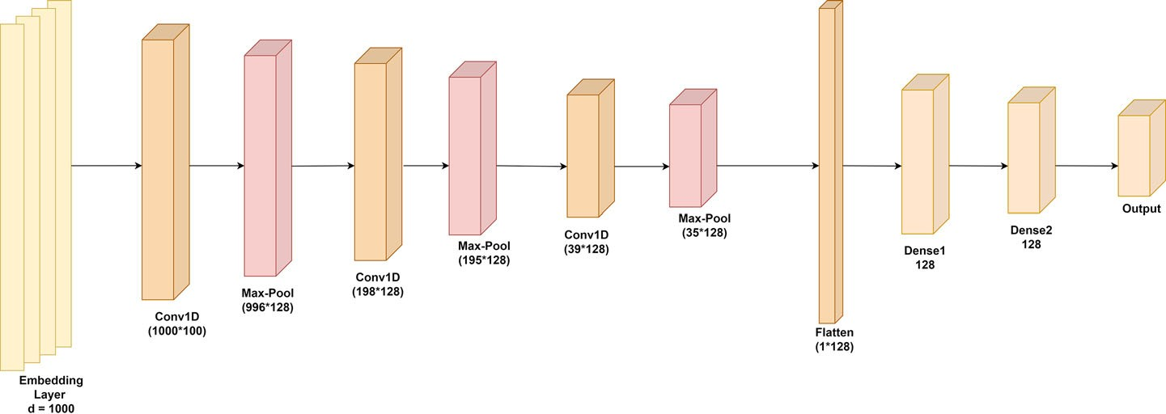

FUTURE WORK:

    - We want to use web scraping and get the data from various social media and websites by ourself and use them in our system.

    - We also want to improve the accuracy by query optimisation

SAMPLE CODE:

IMPORTING THE LIBRARIES:

import numpy as np
import pandas as pd

import matplotlib.pyplot as plt
import seaborn as sns
sns.set()
import string
import re

from gensim.parsing.preprocessing import preprocess_string, strip_tag
s, strip_punctuation, strip_multiple_whitespaces, strip_numeric, remov e_stopwords, strip_short
from gensim.models import Word2Vec

from sklearn import cluster
from sklearn import metrics
from sklearn.decomposition import PCA
from sklearn.manifold import TSNE

READING THE DATASETS:
fake = pd.read_csv('/content/drive/MyDrive/Fake.csv')
true= pd.read_csv('/content/drive/MyDrive/True.csv')

FIND THE NULL VALUES:
print(fake.isnull().sum()) print('************') print(true.isnull().sum())

FILL THE NULL VALUES:

true=true.fillna(' ') fake=fake.fillna(' ')

REMOVE UNNECESSARY DATA:

cleansed_data = [] for data in true.text:
if "@realDonaldTrump : - " in data:
cleansed_data.append(data.split("@realDonaldTrump : - ")[1])
elif "(Reuters) -" in data: cleansed_data.append(data.split("(Reuters) ")[1])
else:
cleansed_data.append(data)

true["text"] = cleansed_data true.head(10)

CLUB TEXT AND TITLE:

fake['Sentences'] = fake['title'] + ' ' + fake['text'] true['Sentences'] = true['title'] + ' ' + true['text']

ASSIGN LABELS FOR THE TEXT:

fake['Label'] = 0
true['Label'] = 1

CONCATINATING TWO DATASETS:

final_data = pd.concat([fake, true])
final_data = final_data.sample(frac=1).reset_index(drop=True)
final_data = final_data.drop(['title', 'text', 'subject', 'date'], axis = 1)

CATEGORIZING WORDS TO REAL AND FAKE:

real_words = '' fake_words = ''
for val in final_data[final_data['Label']==1].Sentences: # split the value
tokens = val.split()

# Converts each token into lowercase
for in range(len(tokens)):
tokens[i] = tokens[i].lower() real_words += " ".join(tokens)+" "

for val in final_data[final_data['Label']==0].Sentences: # split the value
tokens = val.split()

# Converts each token intolower case
for i in range(len(tokens)):

tokens[i] = tokens[i].lower() fake_words += " ".join(tokens)+" "

VISUALIZE REAL WORDS:

from wordcloud
import WordCloud,
STOPWORDS from nltk.corpus
import stopwords
stopwords = set(STOPWORDS)

wordcloud = WordCloud(width = 800, height = 800, background_color ='white',
stopwords = stopwords,
min_font_size = 10).generate(real_words)

# plot the WordCloud image plt.figure(figsize = (8, 8), facecolor = None) plt.imshow(wordcloud)
plt.axis("off")
plt.tight_layout(pad = 0 plt.show()

Output:

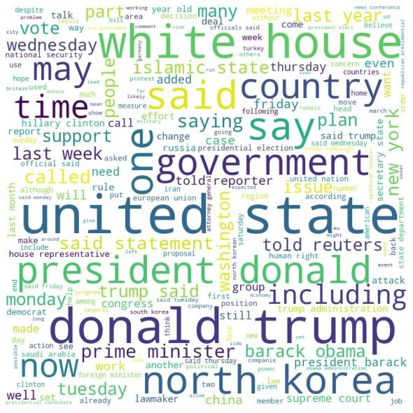

VISUALIZE FAKE WORDS:

wordcloud = WordCloud(width = 800, height = 800, background_color ='white',
stopwords = stopwords,
min_font_size = 10).generate(fake_words)

# plot the WordCloud image plt.figure(figsize = (8, 8), facecolor = None) plt.imshow(wordcloud)
plt.axis("off") plt.tight_layout(pad = 0)

plt.show()
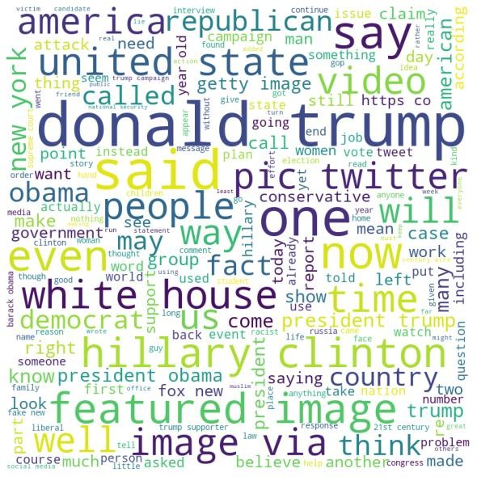

PRE PROCESSING THE TEXT:

To remove urls

def remove_URL(s):

regex = re.compile(r'https?://\S+|www\.\S+|bit\.ly\S+') return regex.sub(r'',s)

1.To convert text to lower case - x.lower()
2.Remove unneseccary spaces at the end - strip_tags
3.To remove url – Above function
4.To remove punctuation  strip_punctuation
5.To remove multiple white spaces in the sentence between words  strip_multiple_whitespaces
6.To remove numbers – strip_numeric

7.To remove stopwords – remove_stopword

CUSTOM_FILTERS = [lambda x: x.lower(), strip_tags, remov e_URL, strip_punctuation, strip_multiple_whitespaces, strip_n umeric, remove_stopwords, strip_short]

processed_data = [] processed_labels = []
for index, row in final_data.iterrows():

words_broken_up = preprocess_string(row['Sentences'], CU STOM_FILTERS)
if len(words_broken_up) > 0: processed_data.append(words_broken_up) processed_labels.append(row['Label'])

print(len(processed_data))
# train=35912
# test=8977

Output of one article after pre processing:

'rallies', 'provide', 'outside', 'security', ['bikers', 'trump', 'travel', 'future',
'paid', 'soros', 'thugs', 'hillary', 'bernie', 'sanders', 'americans', 'know', 'come',
'anarchists', 'whiny', 'petulant', 'college', 'students', 'better', 'angry', 'blm', 'protesters', 'meet', 'group', 'care', 'feelings', 'political', 'correctness', 'large',
LSTM:
To detect fake news using LSTM with Python, you can follow these steps:
Preprocess the data. This includes cleaning the text, removing stop words, and converting the text into a numerical representation.
Train the LSTM model. This involves feeding the preprocessed data to the model and allowing it to learn the patterns in the data.
Evaluate the model. Once the model is trained, you can evaluate its performance on a held-out test set.
Deploy the model. Once the model is evaluated and satisfied with the performance, you can deploy the model to production.
Program:
import numpy as np
import pandas as pd
from tensorflow.keras.models import Sequential
from tensorflow.keras.layers import Embedding, LSTM, Dense

# Load the data
data = pd.read_csv('fake_news_data.csv')

# Preprocess the data
def preprocess(text):
text = text.lower()
text = text.strip()
text = text.replace(',', '')
text = text.replace('.', '')
text = text.replace('?', '')
text = text.replace('!', '')
text = text.split(' ')
return text

data['text'] = data['text'].apply(preprocess)

# Convert the text into a numerical representation
tokenizer = Tokenizer()
tokenizer.fit_on_texts(data['text'])
text_sequences = tokenizer.texts_to_sequences(data['text'])

# Split the data into training and test sets
X_train, X_test, y_train, y_test = train_test_split(text_sequences, data['label'], test_size=0.25)

# Create the LSTM model
model = Sequential()
model.add(Embedding(input_dim=len(tokenizer.word_index) + 1, output_dim=128))
model.add(LSTM(128))
model.add(Dense(1, activation='sigmoid'))

# Compile the model
model.compile(loss='binary_crossentropy', optimizer='adam', metrics=['accuracy'])

# Train the model
model.fit(X_train, y_train, epochs=10)

# Evaluate the model
loss, accuracy = model.evaluate(X_test, y_test)
print('Test loss:', loss)
print('Test accuracy:', accuracy)

# Make predictions on new data
new_text = 'This is a fake news article.'

# Preprocess the new text
new_text = preprocess(new_text)

# Convert the new text into a numerical representation
new_text_sequence = tokenizer.texts_to_sequences([new_text])

# Make a prediction
prediction = model.predict(new_text_sequence)

# Interpret the prediction
if prediction > 0.5:
print('The news article is fake.')
else:
print('The news article is real.')

Here is a sample output of a fake news detection model using LSTM:
Input: Headline: Trump Claims He Won the Election by a Landslide
Body: President Donald Trump on Wednesday claimed that he won the 2020 presidential election by a landslide, despite the fact that he lost by over 7 million votes. Trump made the false claims in a series of tweets, in which he also attacked the media and election officials.
Output: Fake News

Conclusion:
Fake news detection is a challenging task, but it is essential to combat the spread of misinformation and disinformation. Deep learning models such as LSTM and BERT have shown promising results in this area, and their use should be considered to improve the accuracy of fake news detection systems.

